Intro:

Adventurist Robert Swan, "The greatest threat to our planet is the belief that someone else will save it."(MICDS2020GRS_FullPackage) This idea is that we pass down the challenges and mistakes of our generation to the next with the hope that they will fix them. At MICDS, the greater community views this as our responsibility and teaches students the importance of global problem-solving for our current generation while promoting an environmentally conscious mindset for students at MICDS and in the community around us. The Mcdonnell-hall-and-Brauer-hall (MICDS STEM building) was built on May 12, 2015, and was designed to promote an environmentally conscious mindset within the assembled community.

**LEED**

This research project aims to evaluate the efficiency of the Mary Institute and St. Louis Country Day School (MICDS) STEM building. The MICDS STEM building had LEED certification completed on 02.05.2020. LEED certification consists of eight sections where points can be earned: Sustainable Sites, Materials and resources, Water Efficiency, Indoor Environmental Quality, Energy and Atmosphere, Innovation, Materials and Resources, and Regional Priority Credits. It makes a total of eight sections. Each point underneath each section has between 4 and 19 points, earning 110 points. When the STEM building was being built, the head of the project, Robert Shaw, aimed for MICDS to receive gold certification but realized that with a few improvements, we could be platinum-certified, earning a total of 84/110 points. As seen in this scorecard, making several points in all areas shows how the building was designed to be efficient from the start.

There are four levels of certification within LEED. The first one is CERTIFIED, obtained by earning 40-49 points. In St. Louis, 16 buildings are certified. Being the most basic level of certification, many places like Starbucks and Hotels usually receive this level of certification. The next level of accreditation is Silver. The silver category means the building gets between 50-59 points, and 25 buildings in St. Louis have Silver level certification, usually given to university buildings and public buildings (library, zoo, etc.) being the second tier of certification. These places have high efficiency in Energy and Innovation, earning the most points in these two categories. Gold level certification is between 60-79 points. The buildings that receive gold-level certification have high efficiency in all significant areas. As the third highest certification level, it isn't easy to attain. Seventeen buildings in the St. Louis area fit this criteria. Buildings that receive this level of certification are usually significant university buildings and museums. The highest tier is Platinum, earning 80+ points. These buildings are exemplary in all areas of efficiency. They are typically built to be very efficient buildings from the beginning. 137 Buildings in the St. Louis area fit the platinum-level certification. These buildings are usually office buildings, university buildings, and high public traffic buildings (airports, train stations, stadiums).

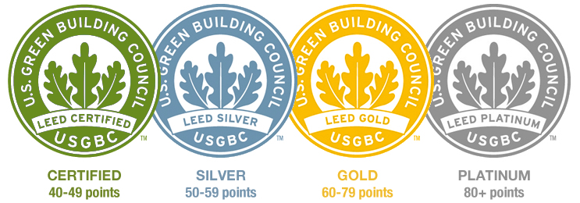

**STEM Building Purpose**

Selected to be next to May Hall, the MICDS STEM building was designed to be a space based on the hope for a greener future. Developing the STEM building was meant to display MICDS's mission to promote an environmentally conscious mindset for students at MICDS and the surrounding community. The design and construction plans were changed many times to fit the standards of the MICDS of design efficiency, labor, and construction costs.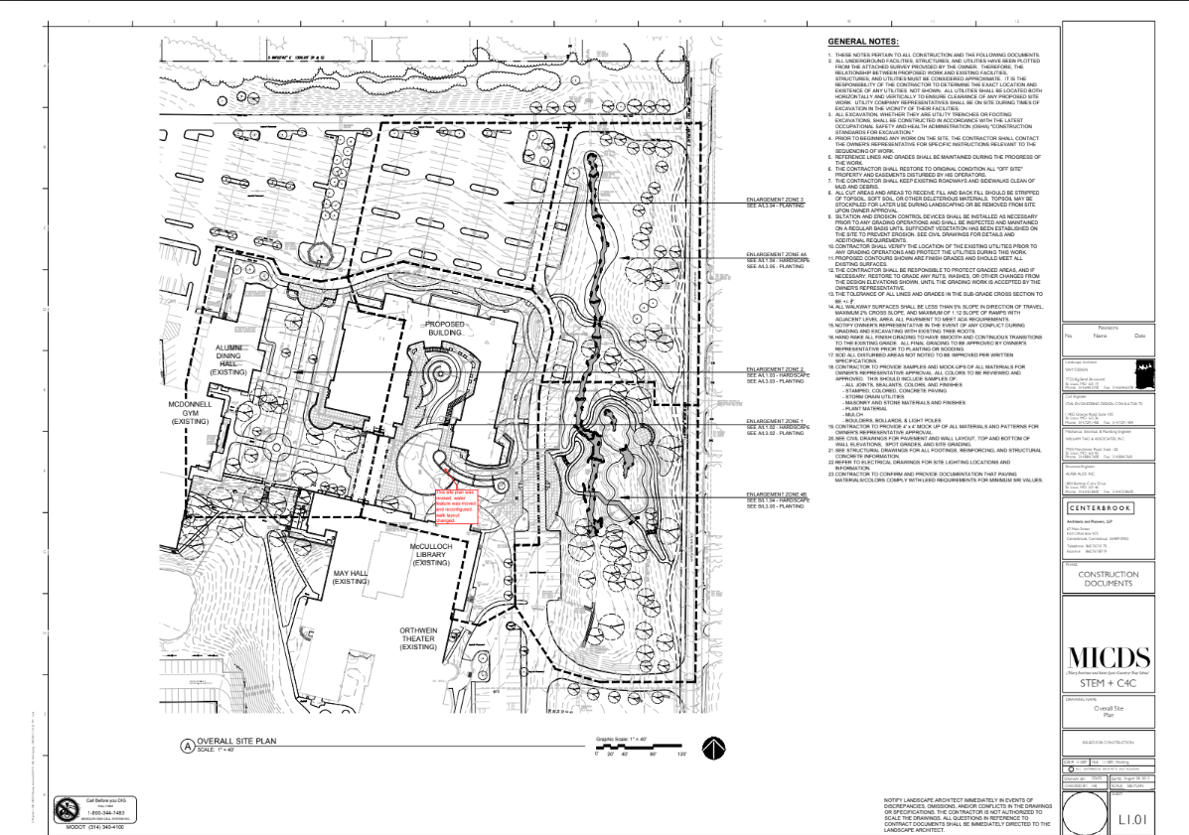

**STEM BUILDING SYSTEMS**

The MICDS STEM building increased efficiency by installing synthetic turf to reduce mowing, painting, and runoff from the athletic fields and playgrounds. State-of-the-art smart irrigation for native plantings that only work during drought conditions uses collected rainwater, low-VOC paints, greenhouse, lighting, HVAC updates, and energy-efficient window replacements.

The 10,000-gallon rainwater tank and 1,100-gallon day tank that stores greywater. Captured rainwear is filtered with UV light for reuse in drip irrigation in many of our native plant reclamation gardens that border buildings. The greenhouse's evaporative cooler effectively reduces the demand for potable water sewage conveyance by 76%. The filtered rainwater is also used throughout the building in low-flow toilet room fixtures, which reduces demand for potable water usage by 64%.

A solar thermal array of over 400SF generates hot water for domestic hot water and ventilation air pre/re-heat. The hot water is also connected to the boiler as a pre-heater. The 100,000-kW solar panel array offsets an estimated 13% of the building's electricity at total capacity. Still, it can be 100% on long sunny days when the load is decreased. The facility will achieve high-energy efficiency through passive solar design; CO2 sensors reduce the amount of electricity used for lighting, heating, and cooling. The CO2 sensors in each classroom detect when the space is occupied and when fresh outside air is required. When classrooms are unoccupied, the mechanical units are turned down to reduce energy consumption.

Our efforts to reduce energy consumption have earned us an 89% Energy Star efficiency rating. Over 35% of the STEM Building products include pre-consumer and post-consumer content, minimizing the impacts from the extraction and processing of virgin materials, and over 50% of this building's materials were sourced within 500 miles of the site. The primary objective of this study is to identify areas where the building's environmental performance may have degraded over the years and to propose innovative solutions for its improvement. Specifically, I will evaluate and enhance various sustainable systems: the 10,000-gallon rainwater tank designed for greywater storage, the thermal array responsible for generating hot water and providing ventilation air, solar panels for clean energy, etc.

**TECHNOLOGY**

The MICDS STEM building, committed to fostering cutting-edge Science, Technology, Engineering, and Mathematics education, represents a significant investment in sustainable construction and eco-friendly technologies. As an integral part of our institution, ensuring that the building remains at the forefront of environmentally responsible design and functions optimally in its capacity to harness and manage resources is crucial. Mr. Shaw suggested to the students and faculty to improve the building over the years by buying and incorporating more Energy Star products into the building design,l improving the efficiencies and the environmental impact of the building. To improve this, I will be returning student and faculty suggestions on improvements to the building design before it was made and creating solutions to enhance and push MICDS's STEM building to fit MICDS's commitment to sustainability through STEM.

Materials and Methods:

Similar to lithium-ion batteries, whenever the UV rays hit the cells, the cells expand; similar to lithium-ion cells, the chemicals mix, degrading battery life. In this way, solar cells easily die due to constant usage. Such as inspecting the solar inverter’s variable direct current output. Inspecting energy drawn from the grid by checking the electrical meter. The surface color of the solar panels is used to check for yellowing and physical damage on the solar panels, such as cracking and solar cells expanding, and the output energy of each cell is observed.

**Solar Panels energy capture**

|  | SUB ARRAY 1 | SUB ARRAY 2 | SUB ARRAY 3 | SUB ARRAY 4 | SUB ARRAY 5 |
| --- | --- | --- | --- | --- | --- |
| MODULES | 96 | 90 | 81 | 83 | 28 |
| kW | 24.48 | 22.95 | 20.66 | 21.16 | 7.14 |
| Shade | 33% | N/A | N/A | 10% | N/A |

Our native plant reclamation gardens, bordered by buildings, have 10,000-gallon and 1,100-gallon rainwater tanks that receive greywater and capture rainwear. Both tanks are UV-filtered to help reuse the water for drip irrigation. The greenhouse's evaporative cooler effectively reduces the demand for potable water sewage conveyance by 76%. The filtered rainwater is also used throughout the building in low-flow toilet room fixtures, which reduces demand for potable water usage by 64%. (Woodard) To ensure safe and clean water supply, it's important to check with the school regarding the maintenance schedule of their UV rainwater filters. Specifically, inquire how often the filters are replaced and how the water is diverted to various sources because filters are usually supposed to be changed every 12 months.

**Rainwater capture (data table, percentages of separation of water)**

|  | Drinking Water | Potable Sewage Water | Other Potable Water |
| --- | --- | --- | --- |
| Percentages | N/A | N/A | N/A |
| Reduction | N/A | 76% | 64% |

* Energy efficiency
* How much is pulled from the grid and given to the grid?

The building operates 55% more efficiently compared to the standard code requirements, resulting in a considerable reduction in energy wastage. Additionally, an on-site Solar Thermal and Photovoltaic system meets 18% of the building's electricity needs. Moreover, 35% of the electricity purchased for McDonnell Hall and Brauer Hall is from renewable resources.

Our STEM building incorporates various sustainable features to improve energy efficiency and reduce costs. For instance, we have installed high-performance glazing on our windows to enhance insulation and make heating and cooling more efficient. Additionally, our interior lighting is programmed to turn off after hours, and our exterior lighting fixture housings are full cutoff to minimize energy waste. Moreover, we leverage natural lighting by strategically using windows throughout the building, which reduces electricity costs and creates a more natural and comfortable environment for our occupants. Using various methods, such as these, the MICDS STEM building is able to reduce the energy used and needed to power the building.

(Seasons, Climate Change, etc)

**Thermal Array energy generated**

|  | Thermal Array | Solar Pannels | Drawn Power |
| --- | --- | --- | --- |
| Power for school generated | 18% | N/A | N/A |
| First year | N/A | N/A | N/A |
| Last Year | N/A | N/A | N/A |

**Uptale**

Using a virtual design program, Uptale organized and illustrated the thermal data of the MICDS Stem building. Various images were then combined to create a virtual walkthrough of the building. This walkthrough allowed people to see and understand the building's ability to retain heat. Using a FLIR CX5 thermal camera, we took pictures of the school to analyze where the building‘s design was flawed and leaking heat outside. To better present this data, we used Uptale to create a VR walkthrough of the building that better shows the analysis of the thermal pictures.

<https://docs.google.com/drawings/d/1DXSwRzv-5ekRjiQ5lhwg4uqXPb8EKVRF197T7FxLlSg/edit?usp=sharing>

**Thermal Readings**

**STEM Picture 1**

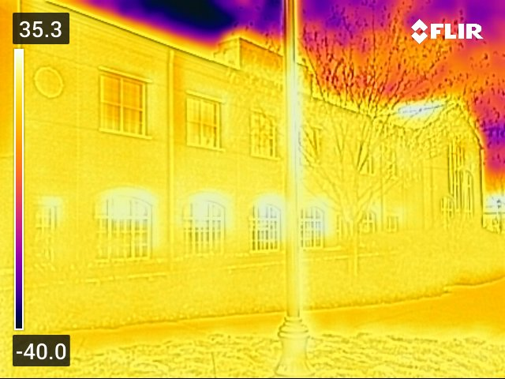

The image shows the building's glass, steel, and concrete structure. Temperature readings are visible, with the numbers "35.3" and "-40.0" appearing multiple times.

The temperature reading of -40.0 is significantly lower than the other temperatures shown in the image, which suggests that it may be an outdoor temperature reading. This could indicate that the building is in a cold climate, and the temperature reading of 35.3 inside the building may indicate the building's ability to retain heat.

A well-insulated building should have a relatively stable temperature throughout, with minimal heat loss. In a thermal image, areas of heat loss may appear as brighter colors, indicating higher temperatures. Based on the information provided, the temperature reading of 35.3 inside the building suggests that it is able to retain heat effectively.

**STEM Picture 2**

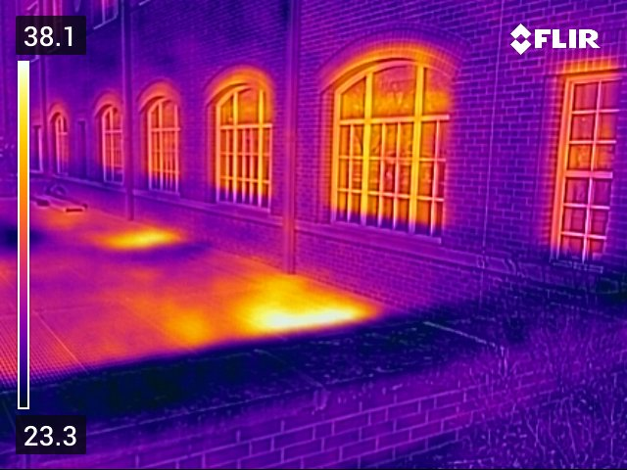

The light source appears to be coming from the left side of the image and casting a warm glow on the building. The temperature readings of 38.1 and 23.3 are visible in the image.

The temperature reading of 38.1 may be indicative of the building's ability to retain heat. However, the temperature reading of 23.3 may be a sign of heat loss.

**360 Photo capture app**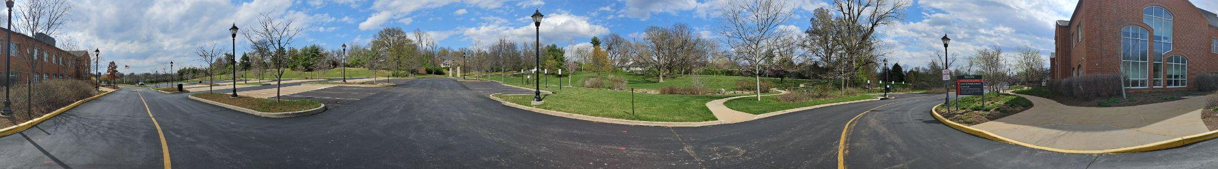

Originally, I used a 360-degree photo capture app on my phone, but since the pictures were not in a 2:1 ratio, they did not scale in Uptale, so I had to change my method of taking pictures of the school.

**Singular Photos Photoshop parsing**

**Image 1**

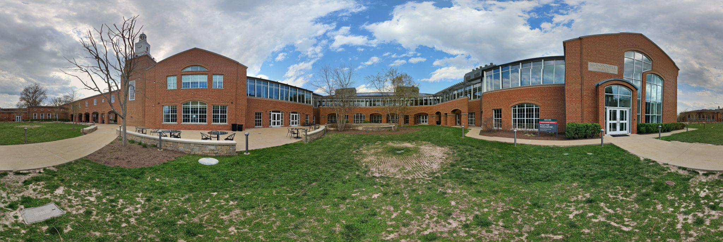

This is the first picture I took. I took about 25 pictures and then combined them using Photoshop. Since it is not in a perfect 2:1 ratio, it is still slightly skewed but much less noticeable.

**Image 2**

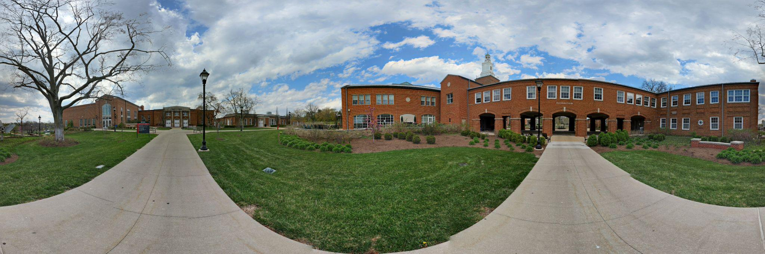

In this picture, you can see the image parsing issues on the sidewalk since my pictures weren't perfectly lined up. There are some issues with some of the pictures like this.

**Uptale VR simulation**

**Image 1**

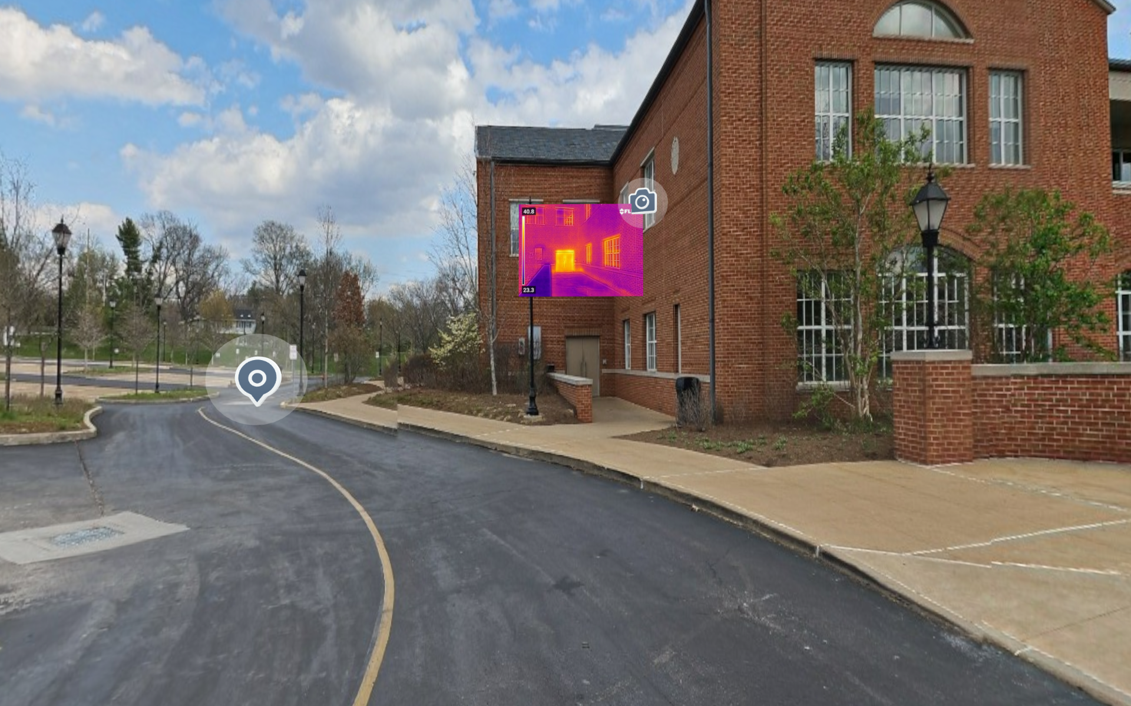

This is one of the pictures I took of my VR simulation. It is the starting point, and from here, people can see and walk through the different thermal pictures.

**Image 2**

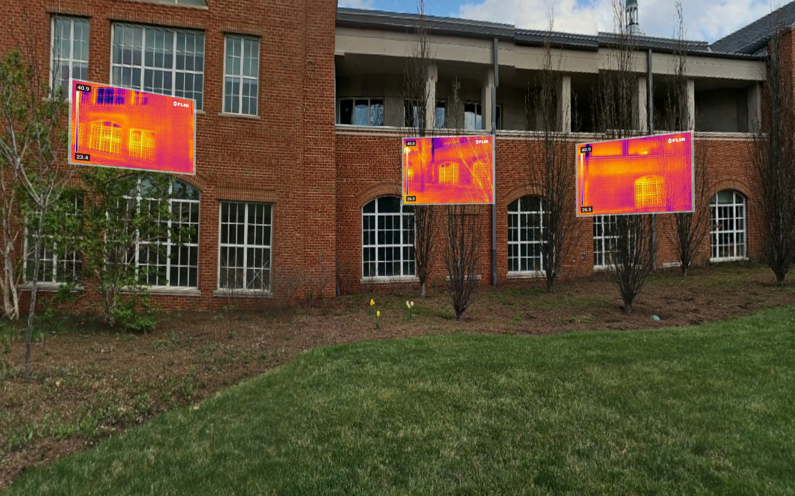

This is the second scene in the simulation here. There are three pictures lined up with the STEM building.

**Image 3**

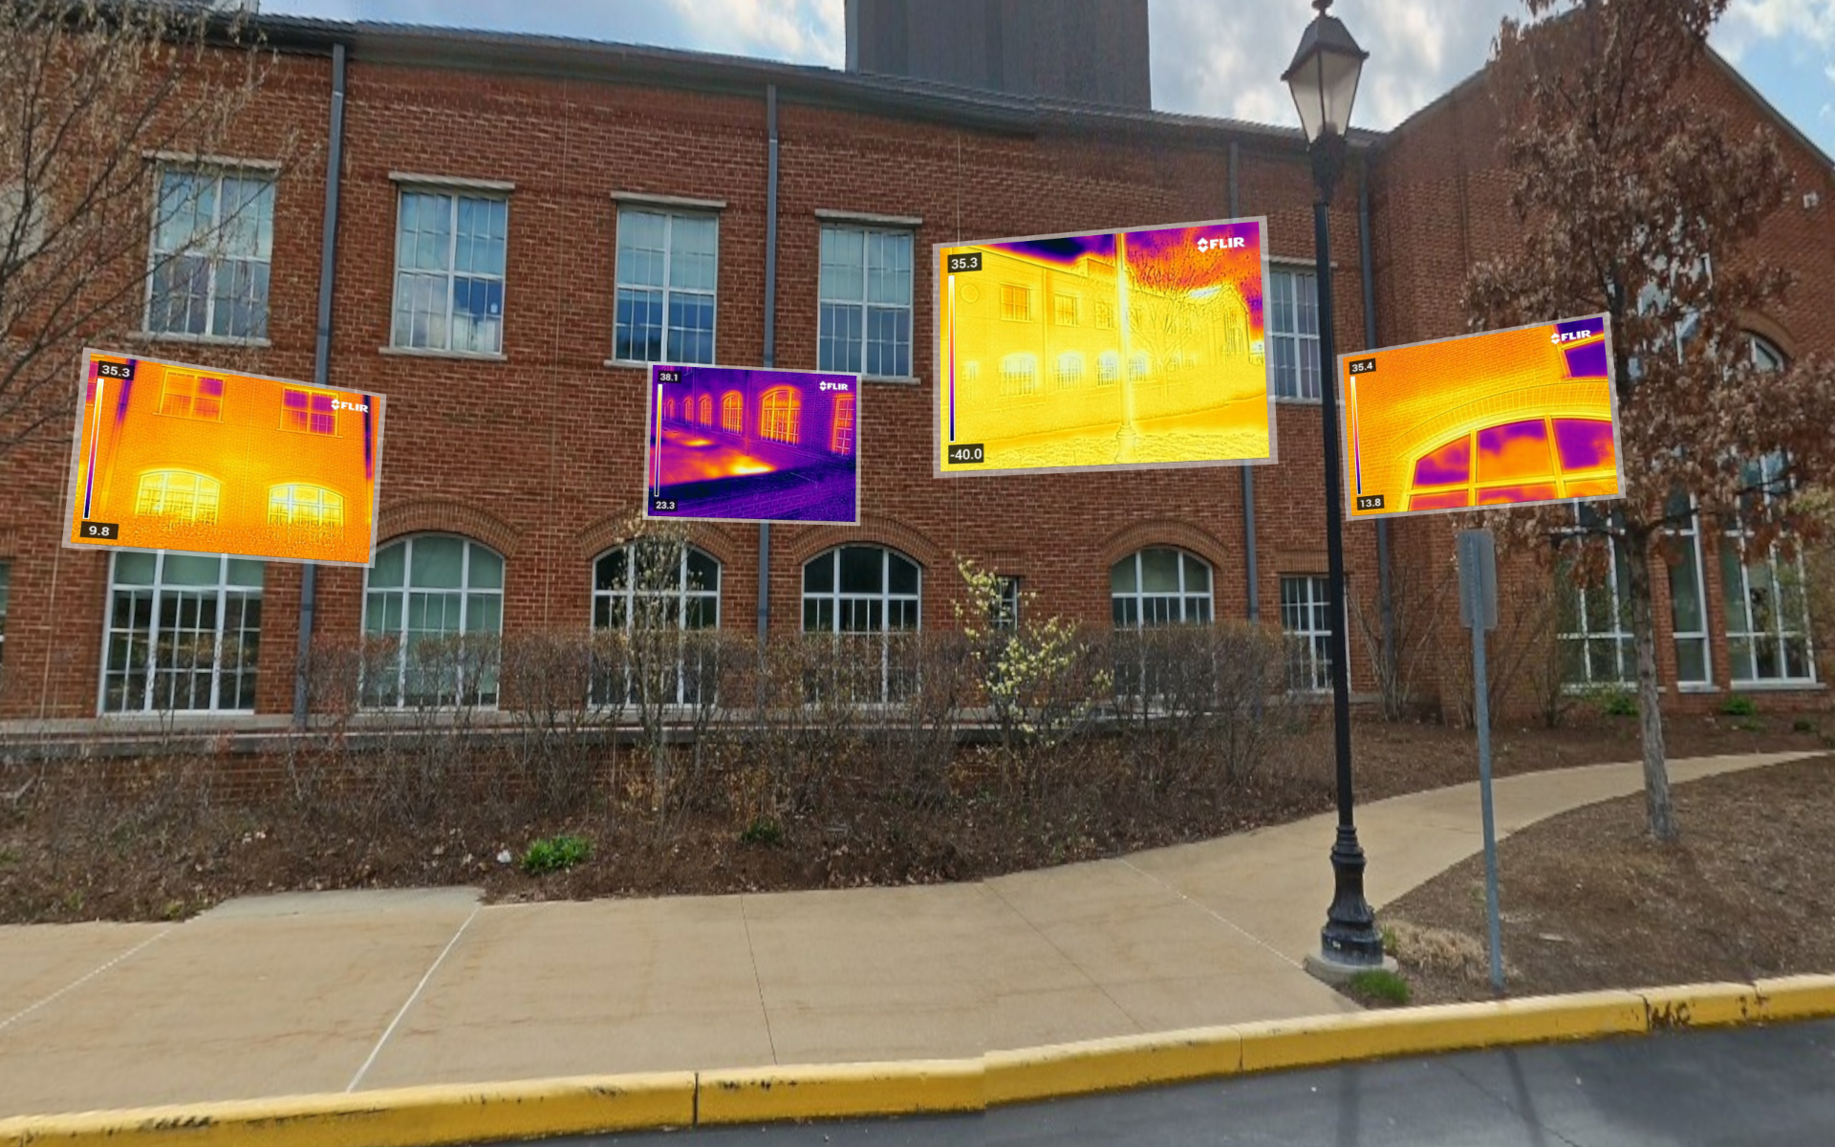

This is another image from the simulation portraying four thermal images lined up with the side of the building.

**Vision Popularity Map**

**Image 1**

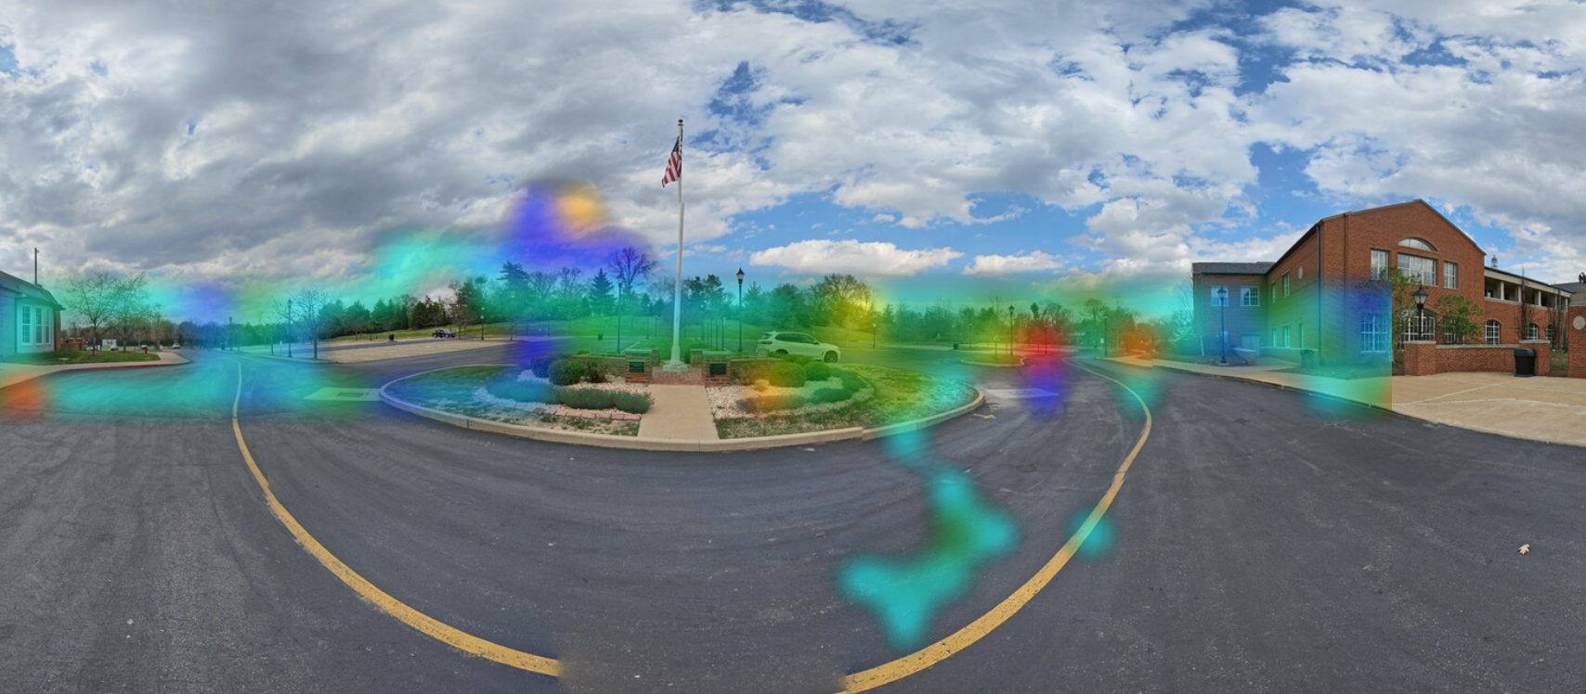

This image shows where people looked; the darker the shade, the more people looked there. I believe the lamppost was the darkest here because that is where the Oculus started the simulation.

**Image 2**

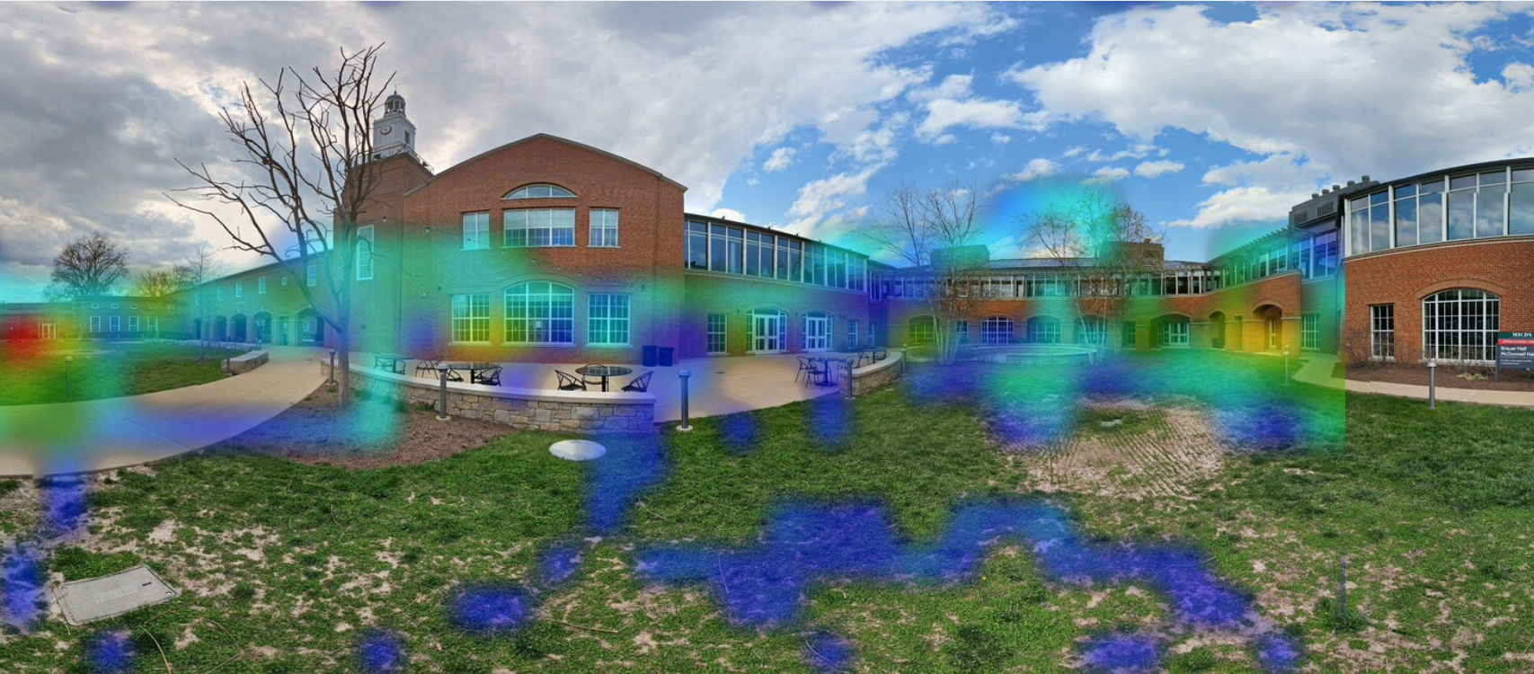

This image is another example of where people looked in the simulation but here you can see it is more sporadic and people were looking at several things not just the thermal images.

**Appendix**

**Additional Resources:**

https://drive.google.com/drive/folders/1akQapY5zULGLhihxtt63HXnBktDdWEeJ?usp=sharing

<https://my.uptale.io/experience/LaunchPage?id=cHwJiteDEOf9LIL9IWZxQ>

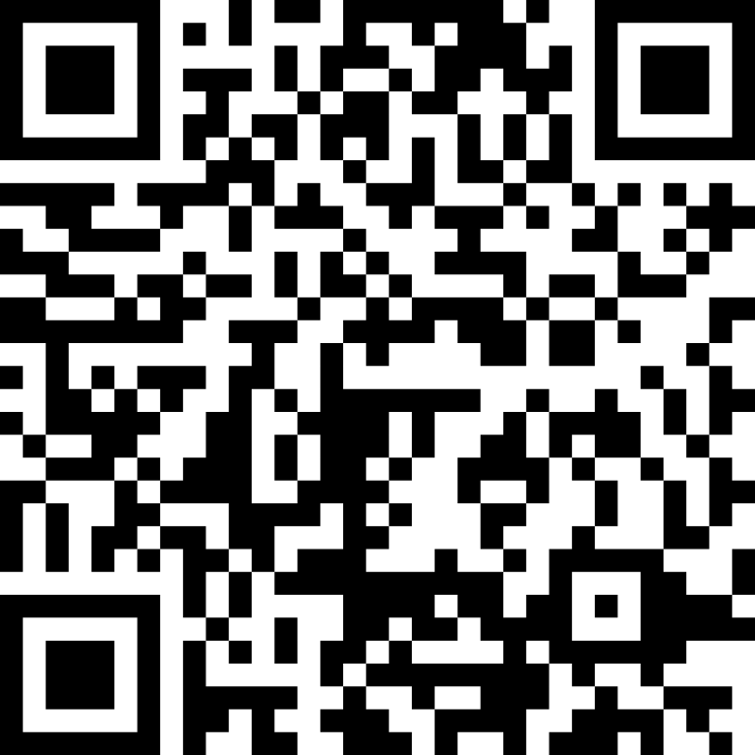

Works Cited

MICDS2020GRS_FullPackage. “MICDS2020GRS_FullPackage.” *Google Docs*, 2020, docs.google.com/document/d/1ZnnwHDBLsD_pVfO0QWFFfosXBvhKfPNrPn6yrVrcK8s/edit. Accessed 14 Dec. 2023.

McDonnell. “McDonnell Hall and Brauer Hall Tour Talking Points.Admissions.docx.” *Google Docs*, 2019, docs.google.com/document/d/1rr3vXnut27e21m7vNA-taIT6TBxBhQRS/edit. Accessed 14 Dec. 2023.

Woodard, John. “What Is a UV Water Purifier and How Does It Work?” *Fresh Water Systems*, Fresh Water Systems, 2023, www.freshwatersystems.com/blogs/blog/what-is-a-uv-water-purifier-and-how-does-it-work#:~:text=An%20ultraviolet%20(UV)%20water%20purifier,microorganisms%20so%20they%20cannot%20reproduce. Accessed 14 Dec. 2023.

‌Notes: <https://drive.google.com/file/d/1Hq0mjX0mXGW7IVz716MsZ5UX4CkTWKwJ/view?usp=sharing>